Stage ##

Bay ##

10 Pistol Staged
10 Rifle Staged Start Sitting in Wagon Seat
6+ Shotgun Staged Hands Holding Reins

R2
R1

S1
S2
P2
P1

R2
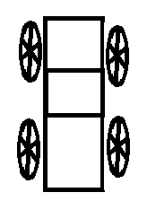

P2

Start sitting on the wagon seat with reins in your hands. All guns are staged on the buckboard platform.
Shooter yells, “Yee Haw!”
ATB:
Pull up the Shotgun Targets, THEN shoot them down. Yes, they start in the down position.

With Rifle, alternate between R1 and R2 for 10 rounds.

Pull back on the reins again, THEN shoot the shotgun targets down.

With Pistols alternate between P1 and P2 for 10 rounds.

Pull back on the reins again, THEN shoot the shotgun targets down.

